# Instructions on how to access the [NAME OF COURSE/PAGES]

The following steps will advise you of how to access the pages via our [open.plymouth.ac.uk](https://open.plymouth.ac.uk) Moodle site. To access the content you will first need to create an account, and once logged in will then need to enrol onto the pages.

## If you already have an account setup, you can:

1. Visit [DIRECT LINK TO COURSE PAGE]
2. Login.
3. Access the content.

## If you do not have an account setup already, you will first need to:

1. Visit <https://open.plymouth.ac.uk/login/signup.php>
2. Enter the required details and then select ‘Create my new account’.
3. You will now be emailed a link, which you will need to open to confirm your email address and finish setting up your account. To confirm your account:
   1. Login to the email address you used to register the account.
   2. Look for the email from [noreply@open.plymouth.ac.uk](mailto:noreply@open.plymouth.ac.uk).   
      **If you cannot find the email in your inbox, check your ‘Junk’ or ‘Spam’ folder. If you cannot find it, please email** [**digitaleducation@plymouth.ac.uk**](mailto:digitaleducation@plymouth.ac.uk) **to state that your account registration email has not been delivered.**
   3. Once you have found the email, open the link in the web address to finish confirming your account.
4. With your account confirmed, visit [DIRECT LINK TO PAGE]
5. Login.
6. In the ‘Enrolment key’ box enter the key ‘KEYTOENROL’ and then select ‘Enrol Me’.   
   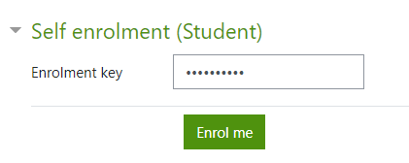
7. You can now access the content.